**Cash Drawer**

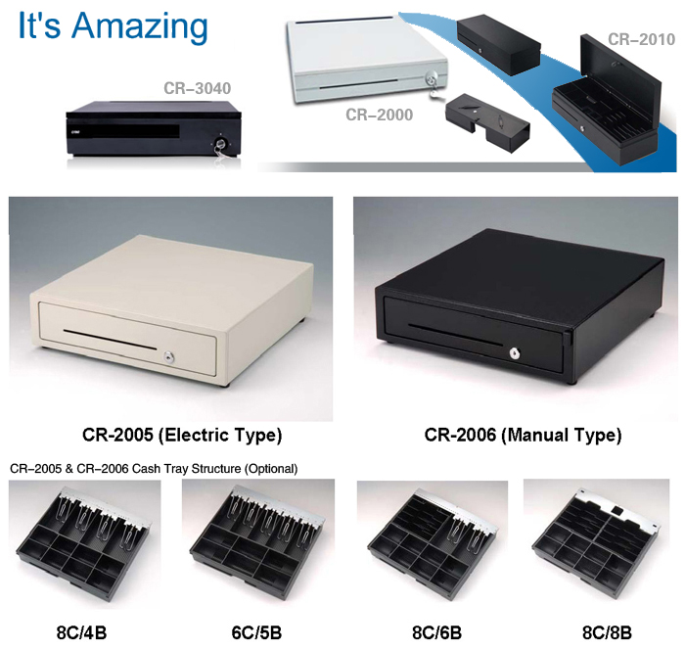

http://b2b-solutions.net/images/stories/demo/specification.gif

|  |  |  |  |  |  |
| --- | --- | --- | --- | --- | --- |
|  | **CR-2000** | **CR-2005** | **CR-2006** | **CR-2010** | **CR-3040** |
| **Coin/Bill Tray (adjustable)** | Up to 5C/5B | 8-10C / 4-5B (Metal Wire Gripper)   8-10C / 6B    (2 Metal Wire and 4 ABS Vertical)   8-10C / 6-8B    (ABS Vertical, adjustable) | | ABS 8C/7B | Up to 5C/5B |
| **Material** | Metal | Metal | | Metal | Metal |
| **Solenoid Release** | 12V-24V | 12V-24V | | 12V-24V | 12V-24V |
| **Open Mode** | Electric | Electric | Manual | Electric | Electric |
| **Interface** | RJ11 | 6-Pin RJ11/12    (Micro. Swith; RS232 for option) | | RJ11 | RJ11/RJ12 |
| **Media Slot** | 1 | 1 | | 1 | 1 |
| **Lock Key** | 3 - Position Manual Lock | 3 - Position Manual Lock | | 3 - Position Manual Lock | 3 - Position Manual Lock |
| **Overall Size** | 400 X 450 X 100 mm | 410 X 415 X 100 mm | | 460 X 170 X 100 mm | 460 X 400 X 100 mm |
| **Cash Tray Size** | 367 X 287 X 67 mm | 359 X 326 X 63 mm | | 450 X 154 X 90 mm | 370 X 290 X 60 mm |
| **Net Weight** | 8.3Kg | 7.2Kg | | 5.3Kg | 8.5Kg |

http://b2b-solutions.net/images/stories/demo/features.gif

* Heavy-Duty Construction
* Three-Position Lock for Maximum Cash Security
* Bill/Coin Tray adjustable
* Stand high scratch hardness